CCS in GCAM (from Candelaria spreadsheets)

Sectors with GCAM:

1. refining,

This sheet has the costs, coefficients, proportion of CO2 captured, inputs and lifetime for biomass refining technologies (with and without carbon capture and storage)

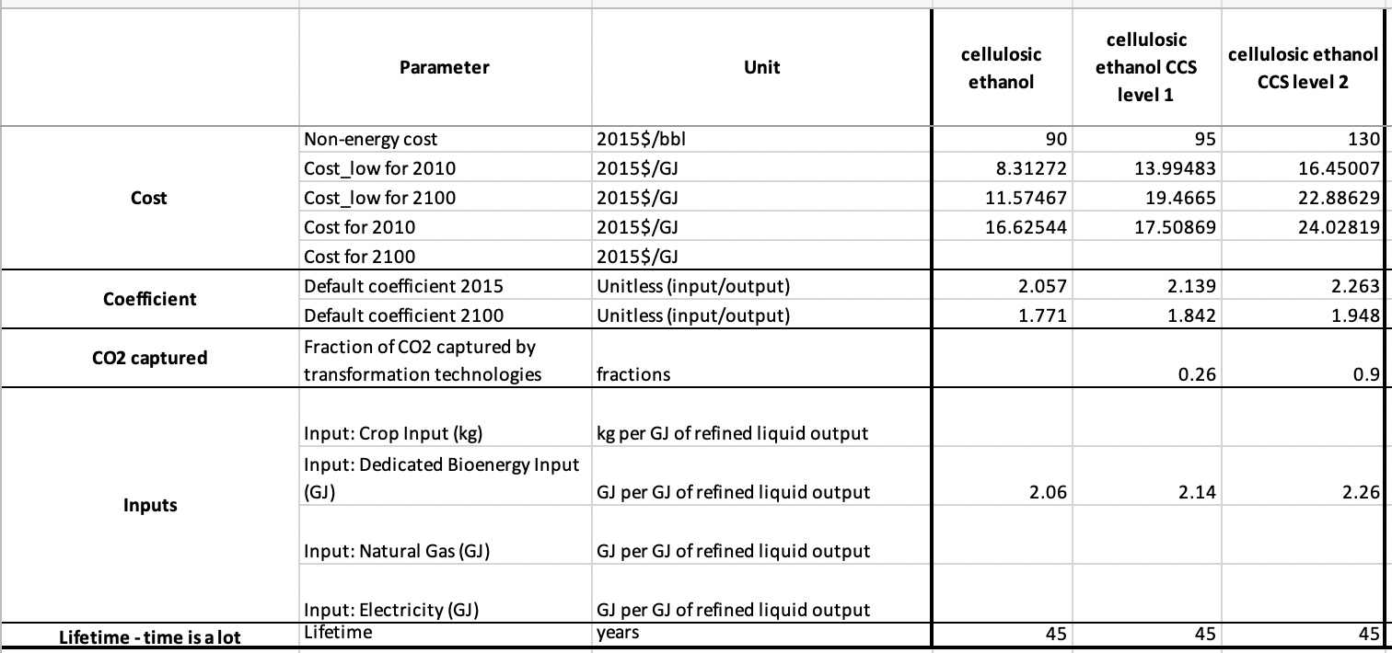

1. Non-energy cost – price per bbl or what?
2. What does Cost_low mean? Cost?
3. What does default coefficient mean -what it is for? (amount of cellulose to the end product)? Basically, it is efficiency of conversion or not really?
4. From non- energy cost and CO2 captured rows: capturing of 26% of total CO2 costs extra 5 2015$ per bbl? And for 90% capturing the extra price per bbl is 35$?
5. Why the input was increased for higher capture? What actually input is?

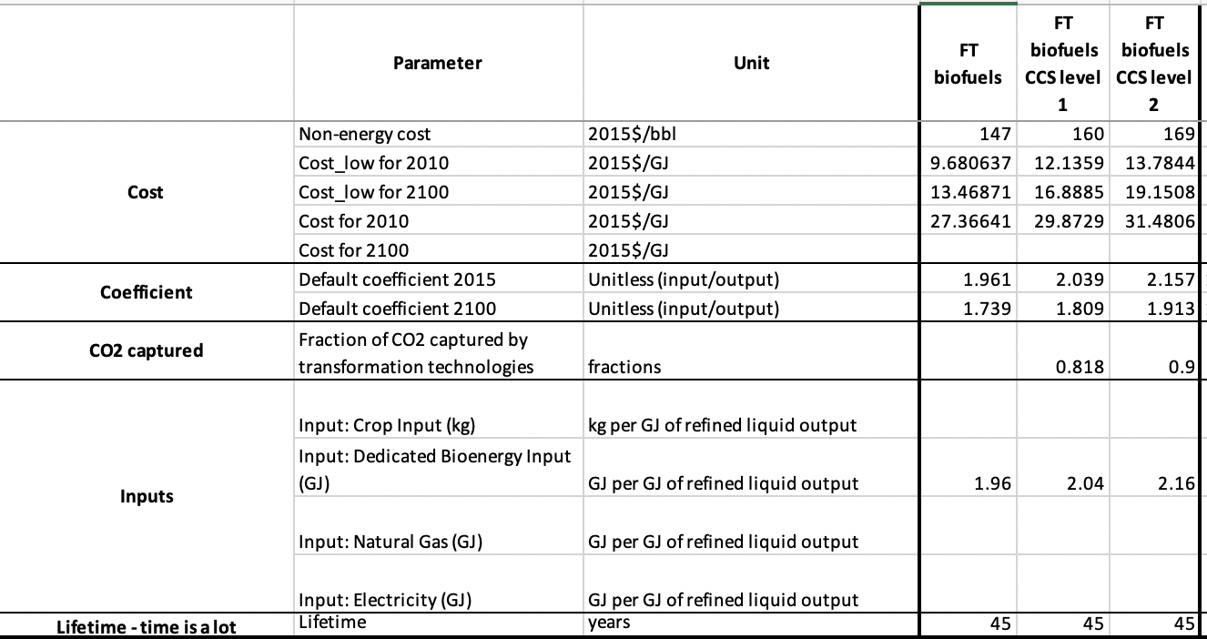

1. What FT biofuel is? - Fischer-Tropsch-fuels ( about the process itself https://www.sciencedirect.com/science/article/pii/B9780081004555000187)
2. How you calculate CCS level? Decide yourself or it is calculated within GCAM? If by yourself why the CCS 1st level is not the same in FT and CE?

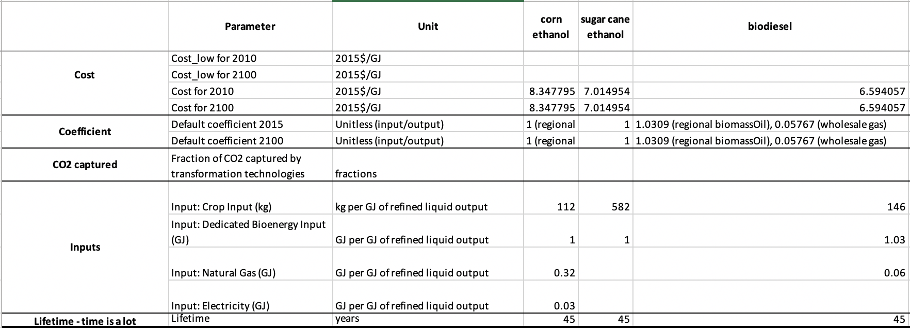

1. electricity,
2. hydrogen production,
3. cement production
4. fertilizer production

Where: